**Medical Store Management**

**ABSTRACT**

This is project is based on the management of the medical store. This project is completed using python. This python projects with source code for Medical Store Management System is primarily based on *Tkinter*. This system has a graphical user interface applied by using the Python programming language and SQLite3.

This *Project System for Medical Store Management* has an easy-to-use interface and is built with respected customer service to allow stock maintenance, database access and electronic documentation for billing purposes. The program also encourages consumer computing discounts, frequent revenue, and identifies measures to avoid possible loss of revenue.

This system platform is best for educational purposes or can be used to simplify the manual maintenance process of records and cash flows by a wide range of retail and wholesale outlets. It’s more versatile and saves you time and money. The Medical Store Management System measures and shows the overall daily sales and also tells the items about the expiry of the coming week.

**INTRODUCTION**

**OBJECTIVES**

* This project is built to check the expire date of the tablets/drugs that are available in the store.
* This can also use to print the bills and to calculate the days income.
* It is used to modify and search the products available in the store.
* It can also be used to add the customers details.

**SCOPE OF THE PROJECT**

* This makes the work of the employee easy, as this stores all type of data in it.
* For instance, the Medical Store Management may help us to find the products that are going to expire or have been expired.
* Furthermore, it can also help us in billing and to find the current day’s revenue.
* It can also use to add/delete any product to the store, and it will modify the available in the store.

**SYSTEM ANALYSIS AND SPECIFICATION**

**PROBLEM DESCRIPTION**

The project is based on a simple problem for the medical store management. Our project’s main aim is to check for the expires dates of the product in the store. Does the medicine match the prescribed dosage by their doctor. Our project also contains the details of the product in the store.

**SYSTEM DESIGN**

**ER DIAGRAM**

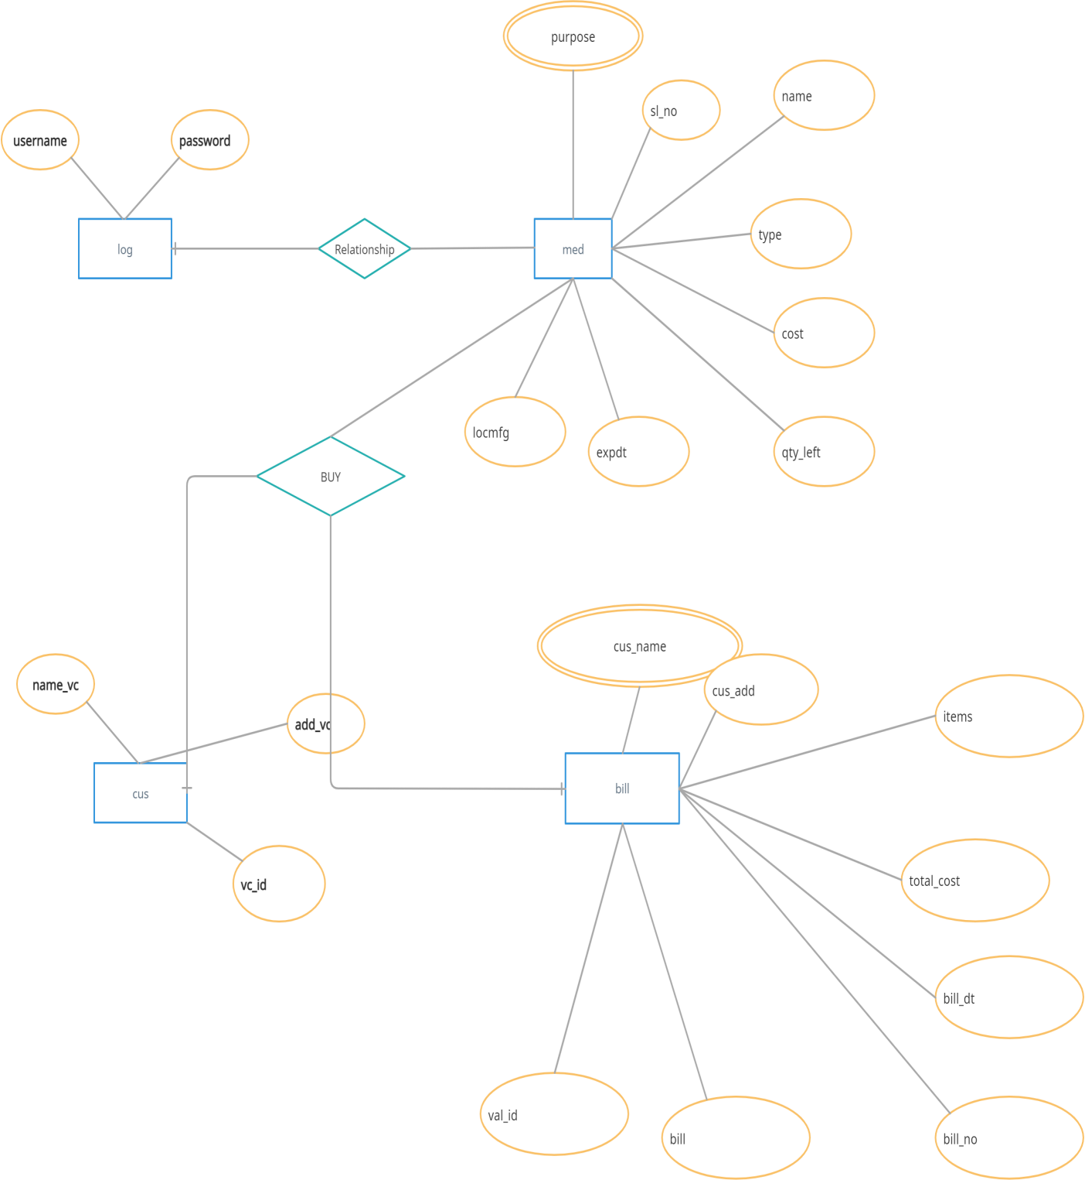

**SCHEMA DIAGRAM**

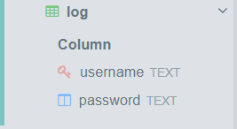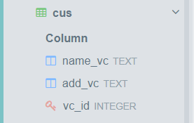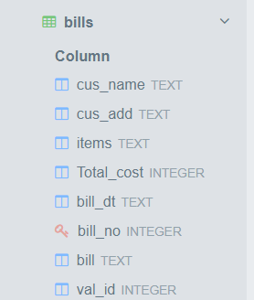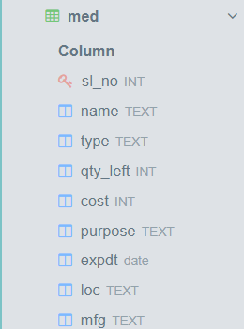

**PROPOSED SOLUTION**

**USER INTERFACE DESIGN**

* + - We use the Tkinter module for the user interface, form Tkinter we used the message box for the same.
    - Also, we used different color to differentiate the activities.

**FUNCTION CONSTRUCTION**

As we use python for the front-end, we created the function using the ‘def’ key word for all the functions that are performed.

All the functions are connected to database to make and save the

changes.

**DATABASE CREATION**

Here we have created two databases namely admin and medicine, which stores the relations/tables.

Medicine database:

1. Bills
2. Cus
3. Med Admin database:

1) Log

**PROJECT DESCRIPTION**

**MODULE DESCRIPTION**

Tkinter:

Tkinter is the standard GUI library for Python. Python when combined with Tkinter provides a fast and easy way to create GUI applications.

Time:

The Python time module provides many ways of representing time in code, such as objects, numbers, and strings.

sqlite3:

Python SQLite3 module is used to integrate the SQLite database with Python.

Random:

Python Random module is an in-built module of Python which is used to generate random numbers.

Tempfile:

Tempfile is a Python module used in a situation, where we need to read multiple files, change or access the data in the file, and gives output files based on the result of processed data.

win32api:

PyWin32 is a library of Python extensions for Windows that enables you to use the features of the Win32 application programming interface (API) on Python.

win32print:

A module encapsulating the Windows printing API.

**sqlite3 CONNECTIVITY**

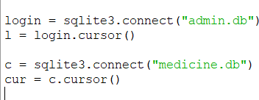

**CONCLUSION AND FUTURE ENHANCEMENT**

**Conclusion:**

Although this is a simple project it can handle a lot of functions such managing the customer’s data, billing, product’s data, it’s expiring data, quantity of the product, type of the cure, saving the bills, etc (int file).

**Future Enhancement:**

The bills can be saved in database and cane be used by the customers for the next time.

Online booking system can be added and to send a copy of the bill to the customer(s).

The address of the customers can also be saved in the database for the easier access.

Also, the online payment method can be adopted for paying the bill.